INTRODUCTION

An actuator is a type of [motor](http://en.wikipedia.org/wiki/Motor) for moving or controlling a mechanism or system. It is operated by a source of energy, usually in the form of an electric current, [hydraulic fluid](http://en.wikipedia.org/wiki/Hydraulic_fluid) pressure or [pneumatic](http://en.wikipedia.org/wiki/Pneumatic) pressure, and converts that energy into some kind of motion. An actuator is the mechanism by which an agent acts upon an environment. The agent can be either an artificial intelligence agent or any other autonomous being.

A mechanical, electrical, or hydraulic device, or their combination, used to effect some predetermined linear,9 rotary, or oscillating movement. An actuator essentially converts hydraulic or air pressure into mechanical force. Basically, there are two types of actuators: single-acting and double-acting. In the single-acting actuator, the piston moves in a single direction as a result of system pressure. In a double-acting system as shown in figure 1.1 the actuator’s piston moves in either direction. The fluid enters from one side of the piston and is drained out of the other. The double-acting actuator may be balanced or unbalanced. In the former case, movement in both directions is equal, whereas in the latter case, the movement to one side is greater than the other.

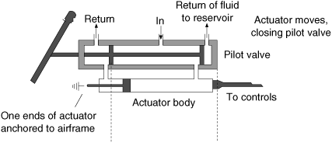

Figure 1.1.The body of the actuator

* 1. **ROLE OF HYDRAULICS IN A TYPICAL AEROSPACE VEHICLEs**

A typical Aerospace vehicle actuation system consists of thrust vector control (TVC) system and aerodynamic control (ADC) system. TVC system consists of Boot strap hydraulic reservoir, a pressure relief valve, a non-return valve, a pump motor package, 4 actuators, 11 hose assemblies (both pressure and return) stainless steel pipe assemblies, hydraulic connectors and TVC linkage systems.

ADC system consists of 4 actuators, 10 hose assemblies, an accumulator, 2 QC/DC nipples, SS pipe assemblies, ADC linkage system, and a charging valve.

Hydraulic actuators achieve the gimballing of the engine in TVC and movement of the control surface in ADC. Each phase of the control scheme i.e. TVC and ADC is provided with a set of actuators. In the TVC phase, each engine is mounted with two actuators in mutually perpendicular directions (planes) for pitch and yaw.

In ADC phase, each of the four control surfaces is connected with an actuator. Total number of actuators in the vehicle is eight. The oil is stored in a bootstrap hydraulic reservoir, which supplies oil to the suction of the pump. The reservoir is self-pressurized piston type. It takes system pressure to develop a suction pressure. A variable delivery axial piston type pump driven by a DC compound motor, pumps the oil from reservoir at a rated system pressure. The electrical supply to the motor is taken from a battery. High-pressure fluid is pumped through a non-return valve and a high-pressure filter. A high-pressure filter relief valve is provided in the pressure line. The outlet of the relief valve is connected to the return line. Two accumulators are connected in line, up-stream to the actuators.

* + 1. **THRUST VECTOR CONTROL( TVC )**

The actuation system is used to guide the aerospace vehicle. The actuators are assembled to the engines such that the thrust created by the engines is properly guided and directed according to the pre-designed path of the missile.

Two actuators are attached to each of the cylinder such every motion is guided. The engines are designed in such a way that to direct the thrust in proper direction as shown in figure 1.2.The linkage mechanism is designed in such a way that it can move about 7degrees in the desired direction to align the missile in the designed path.

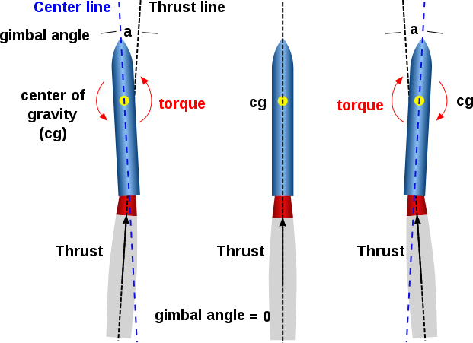

Figure1.2.Thrust vector of an aerospace vehicle

Thrust vectoring, also thrust vector control or TVC, is the ability of an [aircraft](http://en.wikipedia.org/wiki/Aircraft), [rocket](http://en.wikipedia.org/wiki/Rocket), or other vehicle to manipulate the direction of the [thrust](http://en.wikipedia.org/wiki/Thrust) from its [engine](http://en.wikipedia.org/wiki/Engine)(s) or motor in order to [control](http://en.wikipedia.org/wiki/Flight_control) the [attitude](http://en.wikipedia.org/wiki/Attitude_dynamics_and_control) or [angular velocity](http://en.wikipedia.org/wiki/Angular_velocity) of the vehicle.

In [rocketry](http://en.wikipedia.org/wiki/Rocket) and [ballistic missiles](http://en.wikipedia.org/wiki/Ballistic_missile) that fly outside the atmosphere, aerodynamic [control surfaces](http://en.wikipedia.org/wiki/Flight_control_surfaces) are ineffective, so thrust vectoring is the primary means of [attitude control](http://en.wikipedia.org/wiki/Attitude_control)

For aircraft, the method was originally envisaged to provide upward vertical thrust as a means to give aircraft vertical ([VTOL](http://en.wikipedia.org/wiki/VTOL)) or short ([STOL](http://en.wikipedia.org/wiki/STOL)) take-off and landing ability. Subsequently, it was realized that using vectored thrust in combat situations enabled aircraft to perform various manoeuvres not available to conventional-engine planes. To perform turns, aircraft that use no thrust vectoring must rely on aerodynamic control surfaces only, such as [ailerons](http://en.wikipedia.org/wiki/Aileron) or [elevator](http://en.wikipedia.org/wiki/Elevator_%28aircraft%29); craft with vectoring must still use control surfaces, but to a lesser extent.

* + - 1. **Missile**

In a modern [military](http://en.wikipedia.org/wiki/Military), a missile is a self-propelled [guided weapon](http://en.wikipedia.org/wiki/Guided_weapon) system. As mentioned in figure 1.3, Missiles have four system components: targeting and/or guidance, flight system, engine, and warhead. Missiles come in types adapted for different purposes: surface-to-surface and air-to-surface (ballistic, cruise, anti-ship, anti-tank), surface-to-air (anti-aircraft and anti-ballistic), air-to-air, and anti-satellite missiles.

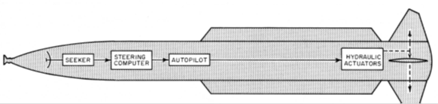

Figure1.3.Hydraulic Actuator in Missiles

* + - 1. **Flight System**

Whether a guided missile uses a targeting system, a guidance system or both, it needs a flight system. The flight system uses the data from the targeting or guidance system to manoeuvre the missile in flight, allowing it to counter inaccuracies in the missile or to follow a moving target. There are two main systems: vectored thrust (for missiles that are powered throughout the guidance phase of their flight) and aerodynamic manoeuvring (wings, fins, canards, etc.).

* + 1. **AERODYNAMIC CONTROL (ADC)**

The aerodynamic control of the missile is maintaining the fin movements. Most guided missiles are controlled and stabilized with movable control surfaces or fins that project from the sides of the missile, typically near its rearward end. The fins, or possibly only a portion of the fins in larger missiles, are normally of symmetrical cross section and are pivotally mounted in the airstream. When each fin is oriented parallel to the airstream, there is no control force exerted on the missile. By pivoting the fins to be oriented at an angle with respect to the airstream, there is a resulting control force exerted on the missile and its direction or roll orientation is changed. The actuators provided to the fins are known as the fin actuators. The fin actuators control the fin movement as we design and path we require and the direction which we want. Some missiles may fly as fast as several times the speed of sound, and therefore control movements of the fins must be accomplished quickly and smoothly in response to a control signal. Control operations and consequent movements of the fins may be updated continuously by the missile electronics or commanded as often as several thousand times per second by a digital computer. The actuator mechanism which converts the electrical command signals to physical movement of the control fins must respond at high rates to maintain the manoeuvrability and stability of the high speed missile, minimizing dynamic behaviour which might otherwise cause the fin not to follow the command exactly.

Two types of fin actuator systems are generally in use today. They are electromechanical systems and fluidic systems. The figure 1.4 shows the model of fin actuation systems. In the former, command signals are translated to physical movement by a sophisticated electric motor, typically with a precision gear train. In the latter, which include both hydraulic and pneumatic systems, the command signal controls pressurizing valves and release valves that regulate the pressure in a cylinder with a movable piston, causing the piston to slide back and forth with in the cylinder. A push rod extends out of the cylinder and is connected to a control fin output shaft upon

which the fin is mounted.



Figure 1.4.Fins

A fin control actuator for missiles carried on aircraft has a device which locks the fin shaft against aerodynamic loads and prevents the transmission of these loads through the drive train. The fin shaft lock includes a plunger which has a cam having a locking portion for engaging the output shaft and preventing the output shaft from rotating in one direction when the plunger is in the locking position. The cam also has a camming portion for engaging the output shaft and pushing the plunger to the retracted position when the output shaft rotates in the opposite direction. The plunger is urged into the locking position by a spring and is held in the retracted position by a permanent magnet. The fin lock device is reusable and does not consume any power after it is set. Comprising in addition, solenoid means for remotely releasing the plunger from the retracted position.

The control actuator must be operable over a wide range of environmental conditions, including temperature, vibration, acceleration, and high structural and fin loadings. For example, some military specifications require that the missile be storable for extended periods and thereafter operable over temperatures ranging from as low as -65° F. to as high as +190° F. The actuator for the control surfaces must be made of materials that achieve satisfactory strength and other properties over the entire environmental range, and additionally must retain its performance in all specified environments.

Many mobile, airborne and stationary applications employ hydraulic control components and servo systems. Hydraulic servo systems can generate very high forces, exhibit rapid responses, and have a high power-to -Weight ratio compared to other technologies. On the other hand, they exhibit a significant nonlinear behaviour due to the nonlinear flow/pressure characteristics, oil compressibility, time varying behaviour, nonlinear transmission effects, flow forces acting on spool and friction, which is not only largely uncertain but is greatly influenced by external load disturbances.

The range of applications for electro-hydraulic servo systems is diverse, and includes Manufacturing systems, materials test machines, active suspension systems, mining machinery, fatigue testing, flight Simulation, paper machines, ships and electromagnetic marine engineering, injection moulding machines, robotics, and steel and aluminium mill equipment. Hydraulic systems are also common in aircraft, where their high power-to-weight ratio and precise control makes them an ideal choice for actuation of flight surfaces.

Apart from the ability to deliver higher forces at fast speeds, servo-hydraulic systems offer several other benefits over their electrical counterparts. For example, hydraulic systems are mechanically “stiffer”, resulting in higher machine frame resonant frequencies for a given power level, higher loop gain and improved dynamic performance. They also have the important benefit of being self-cooled since the driving fluid effectively acts as a cooling medium carrying heat away from the actuator and flow control components. Unfortunately, hydraulic systems also exhibit several inherent nonlinear effects, which can complicate the control problem.

Aerodynamic control surfaces are deployed in aerospace vehicle for generating control forces and moments. In general, the commands issued for this purpose activate an actuation system, which carries out the task of control surface deployment through a series of actions. In case of electro-hydraulic actuation system, hydraulic power, in conjunction with a servo valve, is used to generate the requisite forces and the motion.

The desired motion is achieved through a closed loop feedback control system that senses the actual deflection and corrects it until the desired position is reached. In recent times, there has been a trend towards designing higher agility aerospace vehicles resulting in larger bandwidths, as well as higher actuation rates, of actuation systems.

* 1. **TYPES OF ACTUATION SYSTEMS**

A mechanism to activate process control equipment by use of pneumatic, hydraulic, or electronic signals; for example, a valve actuator for opening or closing a valve to control the rate of fluid flow. There are different types of actuators:

1. Hydraulic
2. Pneumatic
3. Electric.
   * 1. **HYDRAULIC ACTUATION SYSTEM**

By hydraulics, we mean the generation of forces and motion using hydraulic fluids. The hydraulic fluids represent the medium for power transmission.

It is a system where liquid under pressure is used to transmit the energy. Hydraulic systems take engine power and convert it to hydraulic power by means hydraulic pump. This power can be distributed throughout the system by means of tubing. Hydraulic power can be reconverted into mechanical power.

The choice of drive system depends on the following factors:

1. Power consumption
2. Positional accuracy
3. Repeatability
4. Operation
5. Stability
6. Cost and several related factors.
   * + 1. **Advantages of Hydraulic Actuation System**
7. Great power intensity.
8. Precise positioning.
9. Start-up under heavy load.
10. Even movements independent of load, since liquids are scarcely compressible and flow control valves can be used.
11. Smooth operation and reversal.
12. Good control and regulation.
13. Favourable heat dissipation.
14. Overload protection through relief valve.
15. Incompressible, no vibration.
16. No noise.
    * + 1. **Disadvantages of Hydraulic Actuation System**
17. Oil Problems-Because many hydraulic fluids are oil based, hydraulic systems can pose a fire hazard when they leak. These leaks can also pose a safety hazard because hydraulic systems are under high pressure, and fluids can shoot out at a high velocity, potentially harming those nearby the leak.
18. Filters-You must filter oils in hydraulic systems on a regular basis to ensure that the hydraulic fluid contains no broken particles, as well as to eliminate harmful damaging air pockets.
19. Leaks-Hydraulic systems that do not have the necessary hydraulic fluids will not function, which becomes a problem when a leak occurs. You must repair the leak so the hydraulic fluids can continue to produce flow; otherwise, the hydraulic system will begin to slow down . Fortunately, areas that have leakage will also have hotter internal temperatures. Sometimes these very high temperatures cause damage to the vehicle.
20. Aeration-Hydraulic systems can develop loud banging noises, which result from air entering the hydraulic fluids. This banging noise results from the hydraulic fluids compressing and decompressing. This dynamic can also cause foaming, erratic actuator movements, degradation of the hydraulic fluid and damage to the internal parts of the hydraulic system.
    * 1. **PNEUMATIC ACTUATION SYSTEM**

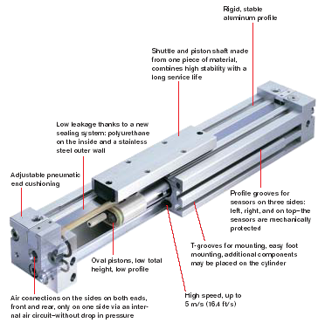

Figure 1.5. Pneumatic Actuation System

A pneumatic actuator converts energy formed by vacuum or compressed air at high pressure into either linear or rotary motion. Pneumatic energy is desirable for main engine controls because it can quickly respond in starting and stopping as the power source does not need to be stored in reserve for operation. The figure 1.5 shows the model of an pneumatic actuation system.

* + - 1. **Advantages of Pneumatic actuation System**

1. Simplicity of realization relatively to small back and forth motions;
2. Sophisticated transfer mechanisms are not required
3. Low cost
4. High speed of moving
5. Ease at reversion movements
6. Tolerance to overloads, up to a full stop.
7. High reliability of work
8. Explosion and fire safety
9. Ecological purity
10. Ability to accumulation and transportation.
    * + 1. **Disadvantages of pneumatic actuation System**
11. Compressibility of the air
12. Impossibility to receive uniform and constant speed of the working bodies movement
13. Difficulties in performance at slow speed
14. Limited conditions – use of compressed air is beneficial up to the definite values of pressure (the cost of compressed air production increases sharply when the pressure in the system exceeds 8…10 bar)
15. Compressed air requires good preparation (the air should be cleared of mechanical impurity and should be free of moisture).
    * 1. **ELECTRIC ACTUATION SYSTEM**

An electric actuator is powered by a motor that converts electrical energy to mechanical torque. The electrical energy is used to actuate equipment such as multi-turn valves. It is one of the cleanest and most readily available forms of actuator because it does not involve oil. The below figure 1.6 shows an model of an electric actuator.

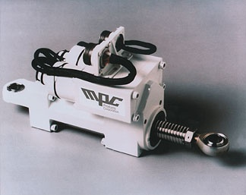

Figure1.6. Electric Actuator

* + - 1. **Advantages of Electric Actuation System**

1. Electricity is easily routed to the actuators; cables are simpler than pipe work.
2. Electricity is easily controlled by electronic units.
3. Electricity is clean.
4. Electrical faults are often easier to diagnose.
   * + 1. **Disadvantages Of Electric Actuation System**
5. Electrical equipment is more of a fire hazard than other systems unless made intrinsically safe, in which case it becomes expensive.
6. Electric actuators have a poor torque - speed characteristic at low speed.
7. Electric actuators are basically rotary motion and complicated mechanisms are needed to convert rotation into other forms of motion.
8. The power to weight ratio is inferior to hydraulic motors.
9. **LITERATURE SURVEY**

However, until the 17th century that the branch of hydraulics with which we are to be concerned first came into use. Based upon a principle discovered by the French scientist Pascal, it relates to the use of confined fluids in transmitting power, multiplying force and modifying motions. Then, in the early stages of the industrial revolution, a British mechanic named Joseph Bramah utilized Pascal’s discovery in developing a hydraulic press. Bramah decided that, if a small force on a small area would create a proportionally larger force on a larger area, the only limit to the force a machine can exert is the area to which the pressure is applied.

* 1. **HYDRAULIC ACTUATION SYSTEM**

Hydraulic Actuators, as used in industrial process control, employ hydraulic pressure to drive an output member. These are used where high speed and large forces are required. The fluid used in hydraulic actuator is highly incompressible so that pressure applied can be transmitted instantaneously to the member attached to it.

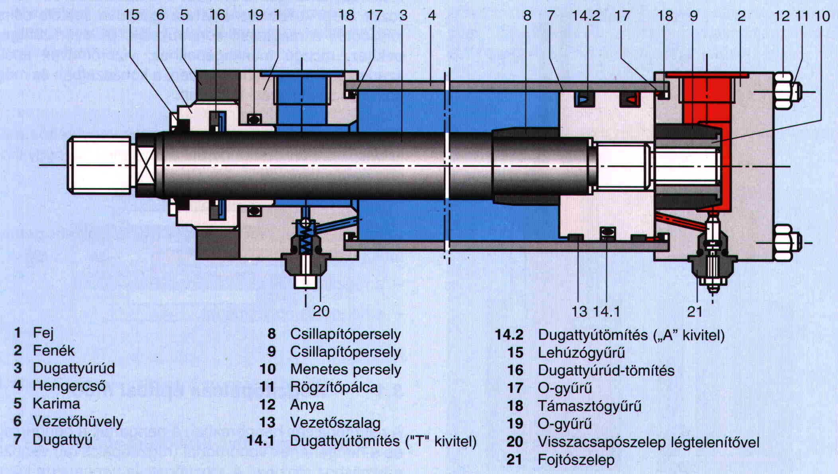

Figure:2.1. Schematic layout of an hydraulic actuator

* 1. **PRINCIPLES USED IN HYDRAULIC ACTUATOR SYSTEM**
     1. **PASCAL’S LAW**

Pascal’s law states that the pressure generated by exerting a force on a confined mass of liquid at rest acts undiminished and in all directions normal to the inside wall of the fluid container. If a force F is exerted on the confined liquid in the jar, a pressure P is generated as shown in the below figure 2.2 and this pressure P is transmitted undiminished and equally throughout the fluid in all directions and acts upon every part of the confining vessel at right angles to its interior surfaces.

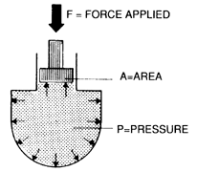

Figure2.2. Forces in the liquid

Since pressure P applied on an area A gives rise to a force F, given as,

F = P×A

Thus, if a force is applied over a small area to cause a pressure P in a confined fluid, the force generated on a larger area can be made many times larger than the applied force that created the pressure. This principle is used in various hydraulic devices to such hydraulic press to generate very high forces.

* + 1. **CONSERVATION OF ENERGY**

Since energy or power is always conserved, amplification in force must result in reduction of the fluid velocity. Indeed, if the resultant force is applied over a larger area then a unit displacement of the area would cause a larger volumetric displacement than a unit displacement of the small area through which the generating force is applied. Thus, what is gained in force must be sacrificed in distance or speed and power would be conserved.

* + 1. **VARIABLE SPEED AND DIRECTION**

Most large electric motors run at adjustable, but constant speeds. It is also the case for engines. The actuator (linear or rotary) of a hydraulic system, however, can be driven at speeds that vary by large amounts and fast, by varying the pump delivery or using a flow control valve. In addition, a hydraulic actuator can be reversed instantly while in full motion without damage. This is not possible for most other prime movers.

* + 1. **POWER-TO-WEIGHT RATIO**

Hydraulic components, because of their high speed and pressure capabilities, can provide high power output with vary small weight and size, say, in comparison to electric system components. Note that in electric components, the size of equipment is mostly limited by the magnetic saturation limit of the iron. It is one of the reasons that hydraulic equipment finds wide usage in aircrafts, where dead-weight must be reduced to a minimum.

* + 1. **STALL CONDITION AND OVERLOAD PROTECTION**

A hydraulic actuator can be stalled without damage when overloaded, and will start up immediately when the load is reduced. The pressure relief valve in a hydraulic system protects it from overload damage. During stall, or when the load pressure exceeds the valve setting, pump delivery is directed to tank with definite limits to torque or force output. The only loss encountered is in terms of pump energy. On the contrary, stalling an electric motor is likely to cause damage. Likewise, engines cannot be stalled without the necessity for restarting.

* 1. **HYDRAULIC FLUIDS AND PROPERTIES**

Hydraulic fluid must be essentially non-compressible to be able to transmit power instantaneously from one part of the system to another. At the same time, it should lubricate the moving parts to reduce friction loss and cool the components so that the heat generated does not lead to fire hazards. It also helps in removing the contaminants to filter. The most common liquid used in hydraulic systems is petroleum oil because it is only very slightly compressible. The other desirable property of oil is its lubricating ability. Finally, often, the fluid also acts as a seal against leakage inside a hydraulic component. The degree of closeness of the mechanical fit and the oil viscosity determines leakage rate.

There have been many liquids tested for use in hydraulic systems. Currently, liquids being used include mineral oil, water, phosphate ester, water-based ethylene glycol compounds, and silicone fluids.  The three most common types of hydraulic liquids are petroleum-based, synthetic fire-resistant, and water-based fire-resistant.

* + 1. **PROPERTIES**

1. **Viscosity** -Viscosity is a measure of a hydraulic fluid's resistance to flow. It is a hydraulic fluid's most important characteristic and has a significant impact on the operation of the system. When hydraulic oil is too thin (low viscosity), it does not seal sufficiently. This leads to leakage and wear of parts. When a hydraulic oil is too thick (high viscosity), the fluid will be more difficult to pump through the system and may reduce operating efficiency.
2. **Compressibility** -Compressibility is a measure of the amount of volume reduction due to pressure. Although hydraulic oils are basically incompressible, slight volume reductions can occur under certain pressure ranges. Compressibility increases with pressure and temperature and has significant effects on high-pressure fluid systems. It causes servo failure, efficiency loss, and cavitation’s therefore, it is important for a hydraulic oil to have low compressibility.
3. **Wear Resistance** -Wear resistance is a hydraulic fluid's ability to reduce the wear rate in frictional boundary contacts. Anti-wear hydraulic fluids contain anti-wear components that can form a protective film on metal surfaces to prevent abrasion, scuffing, and contact fatigue. Anti-wear additives enhance lubricant performance and extend equipment life.
4. **Oxidation Stability** -Oxidation stability is hydraulic oil's resistance to heat-induced degradation caused by a chemical reaction with oxygen. Hydraulic oils must contain additives that counteract the process of oxidation, improve the stability and extend the life of the fluid. Without these additives, the quality of the hydraulic oil will deteriorate quickly.
5. **Thermal Stability** -Thermal stability is the ability to resist breakdown at elevated temperatures. Anti-wear additives naturally degrade over time and this process can be accelerated at higher temperatures. The result of poor thermal stability is the formation of sludge and varnish which can clog filters, minimize flow and increase downtime. In addition, as these anti-wear agents decompose at high temperatures, acids are formed which attack bronze and yellow metals in piston pumps and other hydraulic system components.
   1. **COMPONENTS OF HYDRAULIC ACTUATION SYSTEM**

It consists of the components that hold and carry the fluid from the pump to the actuator. It is made up of the following components. The figure 2.3 shows the circuit diagram about the different components used in an hydraulic actuation system.

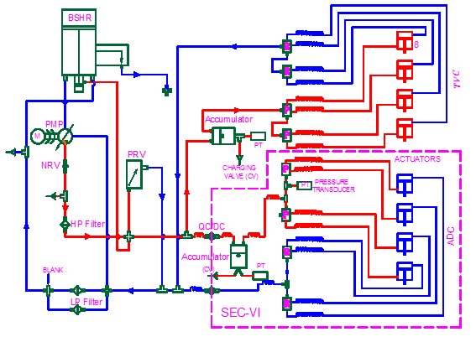

Figure 2.3 Circuit of hydraulic actuation system

* + 1. **RESERVOIR**

It holds the hydraulic fluid to be circulated and allows air entrapped in the fluid to escape. This is an important feature as the bulk modulus of the oil, which determines the stiffness of hydraulic system, deteriorates considerably in the presence of entrapped air bubbles. It also helps in dissipating heat.

**Boot Strap Reservoir**:

A bootstrap uses a differential area piston where high pressure hydraulic pressure from the pump outlet is applied to the small area of the piston. This produces a low pressure on the reservoir side of the piston. A major advantage of bootstrap reservoirs is that reservoir pressurization is maintained during aggressive flight manoeuvres, including negative g flight. Additional hydraulic plumbing and some components are required for bootstrap reservoir implementation (see examples in System Design, Hydraulic Power Generation). Also, note the check valve in the high pressure line. The purpose of this check valve is to maintain reservoir pressure after the pump has shut down so that the pump inlet is maintained when the engine driven pump is not rotating. Accumulators may also be used in this circuit to assist in maintaining pump inlet pressure. The accumulator will be between the check valve and the reservoir.

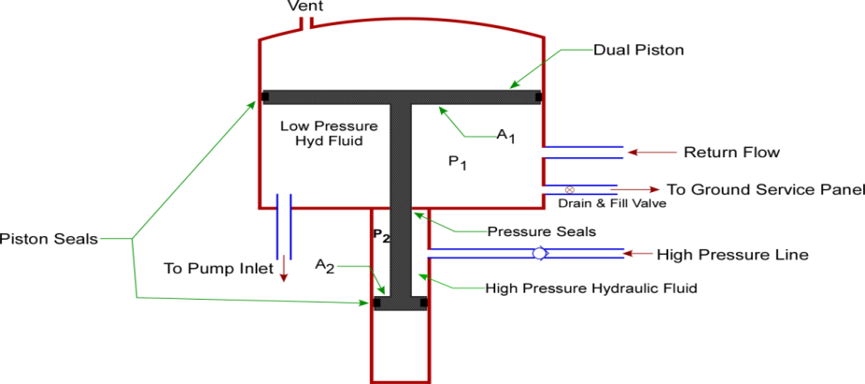

Figure 2.4. Schematic Layout of Bootstrap Reservoir



Figure 2.5. Boot strap reservoir

When the reservoir is at equilibrium P1A1 = P2A2. Since A1>> A2,P1<< P2. The differential piston areas are set by the pump nominal pump outlet pressure and the required level of reservoir fluid pressure.

**Operation:**

The hydraulic pump supplies system pressure to the reservoir connection and acts on the small piston. The force of this pressure is balanced by the induced pressure in the reservoir, which acts on the large main piston. For example, a bootstrap system can be designed so that a 3000 psi system pressure at the small piston will produce 85 psi of reservoir pressure. Depressing the bleed valve stem permits the inner chamber pressures to reduce to ambient pressure, thus bleeding off any entrapped air. The overboard relief valve protects the reservoir assembly from over pressurization.

**Design Highlights**:

1. High reliability
2. Extensive service history
3. Integrated bleed and relief valves
4. Automatic bleed capability
5. Visual and electrical level sensors
6. Temperature compensated level sensor
7. Isolation valves
8. No external high-pressure leak paths
9. Distribution manifold

Compatible with phosphate ester- based and hydrocarbon-based (MIL-PRF-87257, 83282, 5606) operating fluids

* + 1. **FILTER**

The hydraulic fluid is kept clean in the system with the help of filters and strainers. It removes minute particles from the fluid, which can cause blocking of the orifices of servo-valves or cause jamming of spools.

* + 1. **FITTINGS AND SEALS**

Various additional components are needed to join pipe or tube sections, create bends and also to prevent internal and external leakage in hydraulic systems. Although some amount of internal leakage is built-in, to provide lubrication, excessive internal leakage causes loss of pump power since high pressure fluid returns to the tank, without doing useful work. External leakage, on the other hand, causes loss of fluid and can create fire hazards, as well as fluid contamination. Various kinds of sealing components are employed in hydraulic systems to prevent leakage.

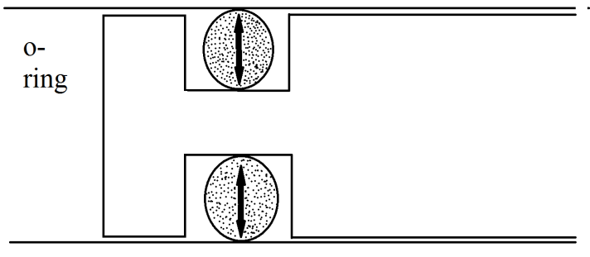

Figure 2.6. O-ring

* + 1. **HYDRAULIC PUMPS**

The pump converts the mechanical energy of its prime-mover to hydraulic energy by delivering a given quantity of hydraulic fluid at high pressure into the system. Generically, all pumps are divided into two categories, namely, hydrodynamic or non-positive displacement and hydrostatic or positive displacement. Hydraulic systems generally employ positive displacement pumps only.

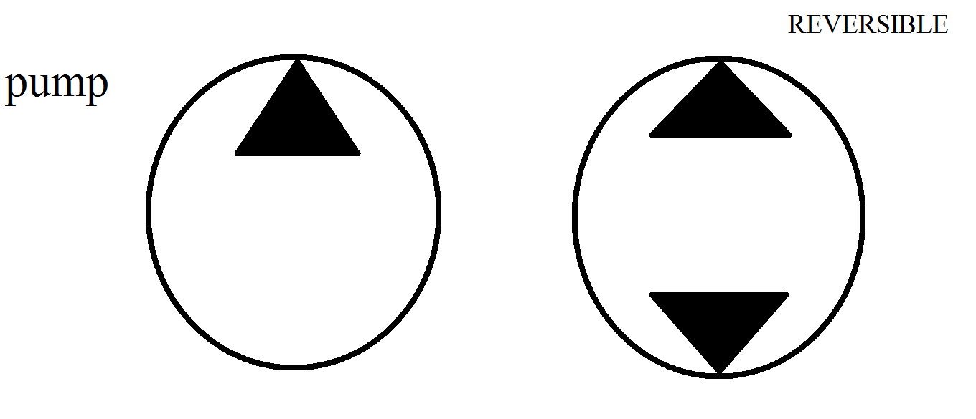

Figure 2.7. Symbol For Pump

* + 1. **MOTORS**

Motors work exactly on the reverse principle of pumps. In motors fluid is forced into the motor from pump outlets at high pressure. These fluid pressures create the motion of the motor shaft and finally go out through the motor outlet port and return to tank. All three variants of motors, already described for pumps, namely Gear Motors, Vane Motors and Piston motors are in use.

* + 1. **ACCUMULATORS**

Unlike gases the fluids used in hydraulic systems cannot be compressed and stored to cater to sudden demands of high flow rates that cannot be supplied by the pump. An accumulator in a hydraulic system provides a means of storing these incompressible fluids under pressure created either by a spring, compressed a gas. Any tendency for pressure to drop at the inlet causes the spring or the gas to force the fluid back out, supplying the demand for flow rate.

* + - 1. **Spring-Loaded Accumulators**

In a spring loaded accumulator, pressure is applied to the fluid by a coil spring behind the accumulator piston. The pressure is equal to the instantaneous spring force divided by the piston area. The pressure therefore is not constant since the spring force increases as fluid enters the chamber and decreases as it is discharged.

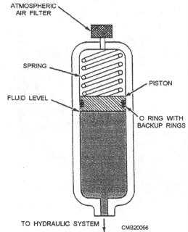

Figure 2.8. Spring loaded accumulators

Spring loaded accumulators can be mounted in any position. The spring force, i.e., the pressure range is not easily adjusted, and where large quantities of fluid are spring size has to be very large.

* + - 1. **Gas Charged Accumulator**

The most commonly used accumulator is one in which the chamber is pre-charged with an inert gas, such as dry nitrogen. A gas charged accumulator should be pre-charged while empty of hydraulic fluid. Accumulator pressure varies in proportion to the compression of the gas, increasing as pumped in and decreasing as it is expelled.

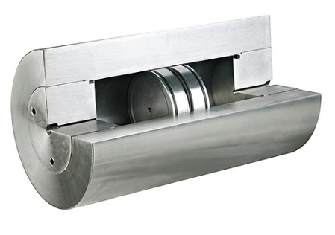

Figure 2.9. Gas charged accumulator

* + 1. **CYLINDERS**

Cylinders are linear actuators, that is, they produce straight-line motion and/or force. Cylinders are classified as single-or double-acting as illustrated in with the graphical symbol for each type.

**Properties:**

1. The cylinders have to be good quality steel with close tolerances.
2. There have to be good sealing both at the piston rod and at the cylinder.
3. With time dirt may come in and damage the surfaces. This has to be possibly reduced.
4. In this case, the leakage will increase all the time.
   * + 1. **Single Acting Cylinder**

It has only one fluid chamber and exerts force in only one direction. When mounted vertically, they often retract by the force of gravity on the load. Ram type cylinders are used in elevators, hydraulic jacks and hoists.

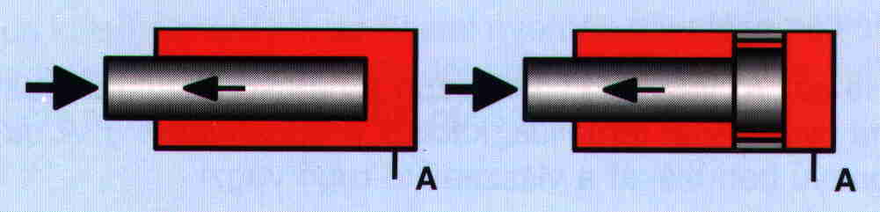

Figure 2.10. Plunger used in single acting cylinder

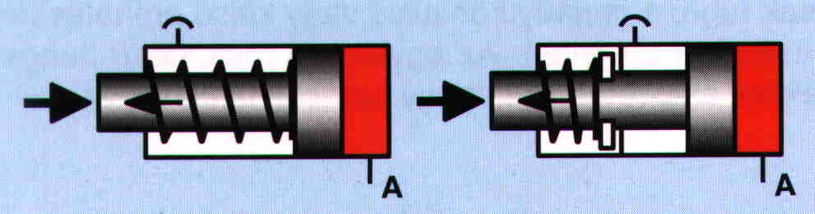

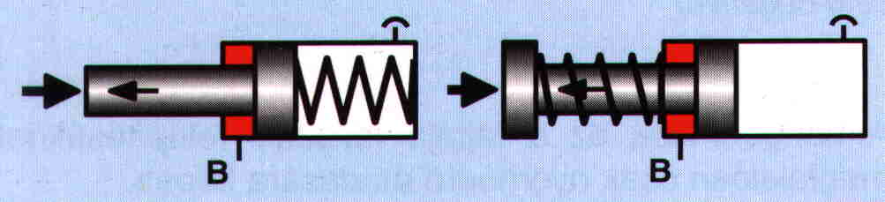

Figure 2.11. pistons used in single acting cylinder

* + - 1. **Double Acting Cylinder**

The double-acting cylinder is operated by hydraulic fluid in both directions and is capable of a power stroke either way. In single rod double-acting cylinder there are unequal areas exposed to pressure during the forward and return movements due to the cross-sectional area of the rod. The extending stroke is slower, but capable of exerting a greater force than when the piston and rod are being retracted.

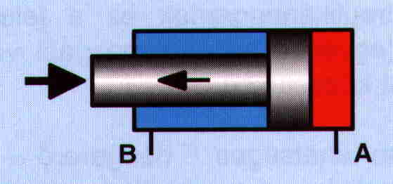

Figure 2.12. Work Is Done In Both Sides

Double-rod double-acting cylinders are used where it is advantageous to couple a load to each end, or where equal displacement is needed on each end. With identical areas on either side of the piston, they can provide equal speeds and/or equal forces in either direction. Any double-acting cylinder may be used as a single-acting unit by draining the inactive end to tank.

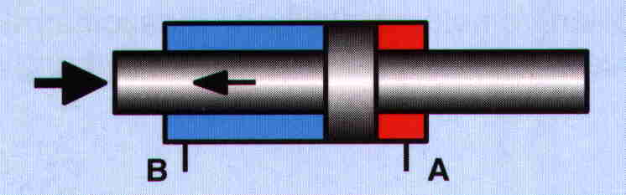

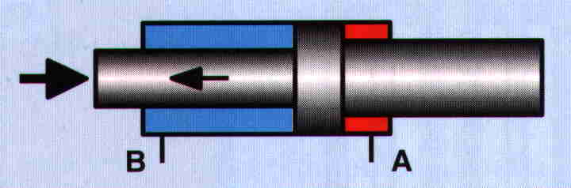

Figure.2.13. Piston rods on both sides

* + 1. **SERVO VALVES**

The servo valve in the missile is used to enhance the flow of fluid into the cylinder according to the desired movement of the piston in the cylinder. The movement of the sloop is controlled by the magnetic force developed by the armature. The sloop movement regulates the fluid flow according to the pressure needed to drive the piston. It has to two oil control ports (c1 & c2) which are regulated by the sloop movement.

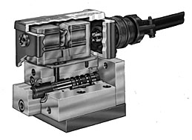

Figure 2.14. Cross section of servo valve

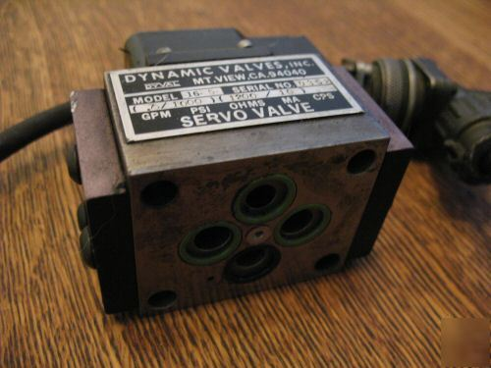

Figure 2.15. Servo valve

A servo valve that is simple, rugged in design and dependable in performance to give superior system control and long trouble free operation.

**Principle of Operation**:

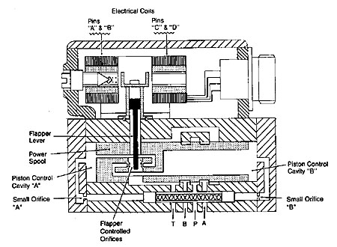

Figure 2.16. Schematic layout of servo valve

* + - 1. **Two-Stage Servo Valves**

The primary stage of a two stage servo valve, shown in Figure "A", is a current driven device. Current in the coils produce a magnetic field which deflects the flapper lever an amount proportional to the current level and in the direction consistent with the direction of current flow.

The movement of the flapper lever upsets the pressure balance positioning the power spool. The power spool then repositions in the direction of the flapper lever so the pressure balance is again maintained.

Although the power of the flapper lever is very small, the hydraulic force amplification generated on the piston control cavities "A" and "B" is enough to accurately position the power spool.

If a positive current flows from pin "A" and "C" to pin "B" and "D", the flapper lever will move to the right as shown in Figure 2.16 at "B". This movement of the flapper effectively throttles the nozzle on the right while de-throttling the nozzle on the left. The result is a pressure increase in cavity "A" which is supplied with fluid from the pressure port thru the small orifice "A". At the same time, the pressure in cavity "B" decreases as it is opened to tank "T" (drain).

The pressure imbalance moves the power spool to the right until the flapper controlled nozzle gaps are equal and pressure in cavities "A" and "B" are once again equal as shown in figure "C". The repositioning of the power spool will to tank or drain port "T result in pressure port “P” being connected control port "B" and control port "A" connected to ".

By reversing the DC current direction from the above example, the flapper and main spool will move to the left and port "P" will be connected to control port "A" and control port "B" connected to tank "T" (drain)

* + 1. **SOLENOID VALVE**

A solenoid valve is an electromechanical device used for controlling liquid or gas flow. The solenoid valve is controlled by electrical current, which is run through a coil. When the coil is energized, a magnetic field is created, causing a plunger inside the coil to move. Depending on the design of the valve, the plunger will either open or close the valve. When electrical current is removed from the coil, the valve will return to its de-energized state.

In direct-acting solenoid valves, the plunger directly opens and closes an orifice inside the valve. In pilot-operated valves (also called the servo-type), the plunger opens and closes a pilot orifice. The inlet line pressure, which is led through the pilot orifice, opens and closes the valve seal.

The most common solenoid valve has two ports: an inlet port and an outlet port. Advanced designs may have three or more ports. Some designs utilize a manifold-type design.

Solenoid valves make automation of fluid and gas control possible. Modern solenoid valves offer fast operation, high reliability, long service life, and compact design.

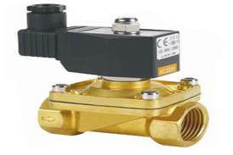

Figure 2.17 Solenoid valve

* + 1. **LINEAR VARIABLE DIFFERENTIAL TRANSFORMER (LVDT)**

The linear variable differential transformer (LVDT) is a type of electrical transformer used for measuring linear displacement (position). LVDTs are robust, absolute linear position/displacement transducers; inherently frictionless, they have a virtually infinite cycle life when properly used. As AC operated LVDTs do not contain any electronics, they can be designed to operate at cryogenic temperatures or up to 1200 °F (650 °C), in harsh environments, under high vibration and shock levels. LVDTs have been widely used in applications such as power turbines, hydraulics, automation, aircraft, satellites, nuclear reactors, and many others. These transducers have low hysteresis and excellent repeatability.

LVDT converts a position or linear displacement from a mechanical reference (zero, or null position) into a proportional electrical signal containing phase (for direction) and amplitude (for distance) information. The LVDT operation does not require an electrical contact between the moving part (probe or core assembly) and the coil assembly, but instead relies on electromagnetic coupling.

**Operation:**

The linear variable differential transformer has three [solenoid](https://en.wikipedia.org/wiki/Solenoid) coils placed end-to-end around a tube. The center coil is the primary, and the two outer coils are the top and bottom secondary’s. A cylindrical ferromagnetic core, attached to the object whose position is to be measured, slides along the axis of the tube. An alternating current drives the primary and causes a voltage to be induced in each secondary proportional to the length of the core linking to the secondary. The [frequency](https://en.wikipedia.org/wiki/Frequency) is usually in the range 1 to 10 [kHz](https://en.wikipedia.org/wiki/Kilohertz)

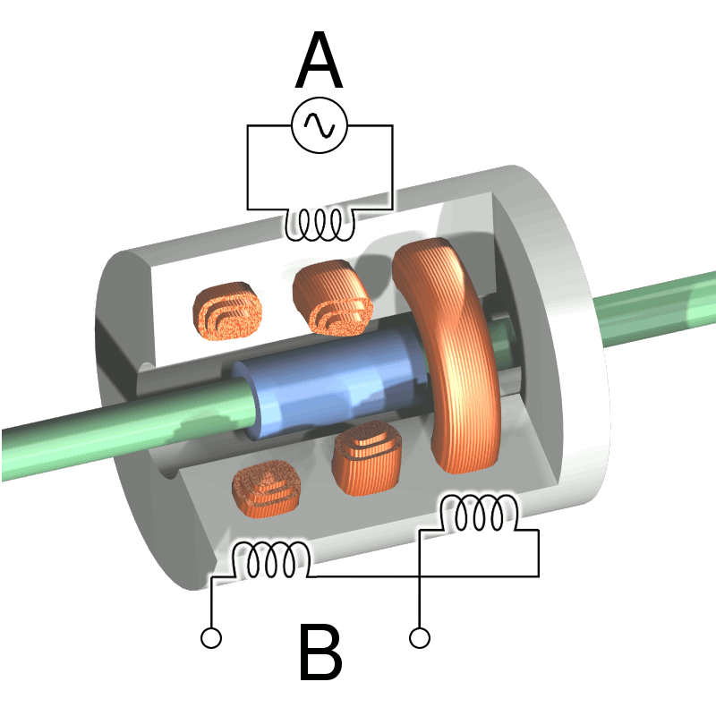

Figure 2.18. Cut way view of an LVDT

The LVDT can be used as an absolute position sensor. Even if the power is switched off, on restarting it, the LVDT shows the same measurement, and no positional information is lost. Its biggest advantages are repeatability and reproducibility once it is properly configured. Also, apart from the uni-axial linear motion of the core, any other movements such as the rotation of the core around the axis will not affect its measurements.

Because the sliding core does not touch the inside of the tube, it can move without friction, making the LVDT a highly reliable device. The absence of any sliding or rotating contacts allows the LVDT to be completely sealed against the environment.

LVDTs are commonly used for position feedback in servomechanisms, and for automated measurement in machine tools and many other industrial and scientific applications.

* 1. **MODELING OF HYDRAULIC ACTUATOR IN CATIA**

The modeling of a hydraulic actuator for typical aerospace vehicle is done by using CATIA V5 R20 Software.

* + 1. **CATIA V5 R20 (Computer Aided Three Dimensional Interactive Application)**

As the world’s one of the supplier of software, specifically intended to support a totally Integrated product development process. Dassault Systems (DDS) in recognized as a strategic partner which can help a manufacturer to the turn a process into competitive advance, greater market share and higher profits and industrial and mechanical design to functional simulation manufacturing and information management.

CATIA Mechanical design solution will improve our design productivity. CATIA is a suit of programs that are used in design, analysis and manufacturing of a virtually unlimited range of the product.

“ Feature based” means that we create parts and assemblies by defining feature like extrusion sweeps, cuts, holes, round and so on instead of specifying low level geometry like lines, areas circles. This means that the designer can think of the computer model at a very high level and leave all low geometry detail for CATIA to figure out.

“Parametric” means that the physical shape of the part as assembly is driven by the value assigned to the attributes of its features. We may define or modify a feature dimension or other attributes at any times. Any changes will automatically propagate through the model.

“Solid Modeling “means that the computer model we create is able to contain all the information that a real solid object would have. It has volumes and therefore, if you provide a value for the density of the material it has mass and inertia.

* + 1. **INDUSTRIES USING CATIA**

CATIA is widely used through the engineering industry, especially in the automotive and aerospace sectors, CATIA V4, CATIA V5 are the dominant systems.

* + - 1. **Aerospace**

The Boeing Company used CATIA to develop its 777 airliner, and is currently using CATIA V5 for the 787 series aircraft. European aerospace giant airbus has been using CATIA since 2001. In 2006 airbus announced that the reduction of it airbus 380 using CATIA. Canadian aircraft maker bombardier aerospace has done all if its designing on CATIA.

* + - 1. **Automotive**

Automotive Companies that use CATIA to varying degrees are BMW. Porsche, Daimler, Chrysler, Audi, Volvo, fiat, Gestamp Automaocian, benteler AG PSA, Pevgcot Citroen, Penault, Toyota, Honda, ford Scania, Hyundai proton (company), TATA motors and Mahindra Goodyear uses it in making tires for automotive and aerospace and also uses a customized CATIA for its design and development. All automotive companies sue CATIA for car structures door beams IP supports, root rails, side rails, body components because CATIA is very good in surface creation and computer representation of surfaces.

* + - 1. **Shipbuilding**

Dassault system has begun serving shipbuilders with CATIA V5 release 8. which includes special features useful to shipbuilders, GD Electric boat used CATIA to design the latest fast attack submarine class for the united states Navy, the virgina class, Northrop Grumman Newport news also used CATIA to design the Gerald R.Ford class of supper carries for us navy.

* + 1. **GEOMETRIC MODELLING**

There are number of applications of the CAD software, one of the most popular applications being geometric modeling. First of all let us see what is geometric modeling? The computer compatible mathematical description of the geometric of this is called as geometric modeling. The CAD software allows the mathematical description of the object to be displayed as the image on the monitor of the computer

* + - 1. **Steps For Creating The Geometric Model**

There are three steps in which the designer can create geometric models by using CAD software, these are

1. **Creation of basis geometric objects**: In the steps the designer creates basic geometric elements by suing commands like points, lines and circles.
2. **Transformations of the elements:** In the second step the designer uses commands like achieve scaling, rotation and other related transformation of the geometric elements.
3. **Creation of the geometric model**: During the final step the designer uses various commands to that cause integration of the objects or elements of the geometric model to form the desired shape.

During the process of geometric modeling the computer converts various commands given from within the CAD software into mathematical models, stores them as the files; and finally displays them as the image. The geometric models created by the designer can open at any time for reviewing, editing or analysis.

* + 1. **MODULES IN CATIA**
       1. **Sketcher Module**

Most components designed using CATIA V5 is a combination of sketched features placed features and derived features. The placed features are created without drawing a sketch, whereas the sketched features require a sketch that defines its shape. Generally, the base feature 7f any design is a sketched feature.

The sketcher workbench provides the space and tools to draw sketches of the solid model. Generally, the first sketch drawn to start the design is called the base sketch, which is then converted into base feature. However, once one gets familiar with the advanced options of CATIA V5, one will also be able to use a derived feature or a derived part as the base feature.

* + - 1. **Assembling Module**

Assembly modeling is the process of creating designs that consists of two or more components assembled together at their respective work positions. The components are brought together and assembled in the Assembly Design workbench by applying suitable parametric assembly constraints to them. The assembly constraints allow you to restrict the degrees of freedom of the components at their respective work positions. The assembly files in CATIA V5 are called product files.

* + 1. **DRAFTING WORK BENCH**

After creating parts and assembly them, we need to generate their drawing views. A 2D drawing is the life line of all the manufacturing systems because on the shop floor or tool room, a machinist mostly needs the 2D drawings for manufacturing. CATIA V5 provides us with the drafting workbench, which is the specialized environment for generating 2D drawing views. This workbench provides all tools required to generate drawing vies, modify, and apply dimensions and annotations to them. In other words, we can get the final shop floor drawing using this workbench of CATIA V5. There are two types of drafting techniques to CATIA V5: Generative drafting and Interactive drafting. Generative drafting is a technique of generating the drawing views using a solid model or an assembly model. Interactive drafting is a technique, in which the sketcher tools are used to draw the 2D drawing views.

* + - 1. **Wireframe And Surface Designing**

The product and industrial designers give special importance to product styling and providing unique shape to components. Generally, this is done to make product look attractive and presentable. Most of the times, the product’s shape is managed using the surface modeling techniques. Surface models are three-dimensional models with no thickness and do not have mass properties. CATIA V5 provides a number of surface modeling tools to create complex three-dimensional surface models. Various workbenches in CATIA V5 with surface creation tools are:

* 1. Wireframe and Surface Design
  2. Generative Shape Design
  3. Freestyle
     + 1. **DMU Kinematics**

This workbench is used to create and edit different mechanisms. Also, it is used to study and check the working of mechanisms. In this workbench, you can simulate and analyze the mechanisms dynamically. Therefore, it is easy and convenient to check the limits and interferences of different parts of the mechanism.

In DMU Kinematics, minimum two parts are required to create a mechanism. We can keep one part of the mechanism fixed and move the other part with respect to the fixed part to analyse various functions of the mechanism.

We can design mechanism by creating joints manually using the tools available in the Kinematics Joints drop-down in the DMU Kinematics toolbar. Alternatively, we can create them automatically by using assembly constraints.

Until now a lot of work has been done on control, operation and testing of hydraulic systems. With the evolution of computer simulation techniques, this process has become much simpler. In this chapter works published in a wide spectrum of journals have analysed and the goals for the present study have been given a firm foundation with the information derived from the survey. They are presented in the subsequent sections.

The mathematical model for the hydraulic System is made with the help of system characteristics and its behaviour.

Pramod [1] studied the effect of non-linearity in the configuration design of Digital Auto Pilot (DAP) in launch vehicles. An electro hydraulic actuator model of a launch vehicle control system is considered for analysis of non-linearity. Various non-linear effects like saturation (in current and stroke limit), dead zone and coulomb friction are taken into account. DAP, which is an interface between the guidance system and control system, is designed to cater to the model (linear/ non-linear) adopted for the actuator. In the actuator alone case, without considering the total flight regime and vehicle model, the performance is found to be satisfactory for linear as well as non-linear actuator models. In the actuator–vehicle combination, when the simulation is carried out for the total flight regime considering the vehicle model, the performance of the linear / nonlinear actuator model is dependent on DAP configuration this study brings out the fact that the DAP configuration is specific to the actuator model, so that satisfactory performance of launch.

vehicle control system can be ensured only by choosing proper configuration for DAP, based on consideration of non-linearity’s in actuator model.

Evangelos Papadopoulos [2] presented an optimal hydraulic component selection for electro hydraulic systems used in high performance servo tasks. Dynamic models of low complexity are proposed that describe the salient dynamics of basic electro hydraulic equipment. Rigid body equations of motion, the hydraulic dynamics and typical trajectory inputs are used in conjunction with optimization techniques, to yield an optimal hydraulic servo system design with respect to a number of criteria such as cost, weight or power. The optimization procedure employs component databases with real industrial data, resulting in realizable designs.

Edson Roberto [3] studied the problem of experimental control of hydraulic actuators is considered. To deal with mechanical and hydraulic uncertainties a different controller is synthesized: a back stepping controller. Experimental results of both implementations are analysed in the context of practical difficulties, mainly the measurement of acceleration. These results illustrate the main features of these controllers when applied on a hydraulic actuator.

Kexiangwei [4] developed a fluid power control unit using electro rheological fluids. Electro Rheological (ER) fluids can change their rheological properties when subjected to an electrical field. By using ER fluids as the working medium in fluid power systems, direct interface can be realized between electric signals and fluid power without the need for mechanical moving parts in fluid control unit. The pressure drop and flow rate can be directly controlled through the change of applied electric fields. This paper investigates the design and controllability of ER fluid power control system for large flows. The design criterion for an ER valve is proposed and four ER valves are manufactured based on this criterion. A fluid control unit consisting of an ER valves bridge circuit is constructed, the characteristics of which are theoretically and experimentally investigated. The results show that the ER fluid control units have better controllability for fluid power control.

Holger Berndt [5] presented an interactive design and simulation platform for flight vehicle systems development. Its “connect-and-play” capability and adaptability enable “on-line” interaction between design and simulation during the integrated development. As a case study, the implementation of the proposed platform and an aircraft flight control system development example are demonstrated on an experimental test bed including a real time Systems simulator.

Anderson [6] in his paper presented a nonlinear dynamic model for an unconventional, commercially available electro hydraulic flow control servo valve is presented. The two stage valve differs from the conventional servo valve design in that: it uses a pressure control pilot stage; the boost stage uses two spools, instead of a single spool, to meter flow into and out of the valve separately; and it does not require a feedback wire and ball. Consequently, the valve is significantly less expensive. The proposed model captures the nonlinear and dynamic effects.

Ashok Joshi [7] in his papers presented the effects of servo valve nonlinearity, actuation compliance and friction related nonlinearity on the dynamics of a flight control surface, during its deployment through an electro-hydraulic actuation system. Starting from the pilot command, a realistic model of the electro-hydraulic actuation system is evolved, which includes the command lags, servo valve nonlinearity, actuation chain compliance and friction nonlinearity. A realistic mathematical model for the control surface motion, under the action of the actuator forces and the aerodynamic and inertia forces is postulated, using subsonic incompressible aerodynamics.

Peter Rowland, M. Longvitt, Keith Austin and Irfan Bhatti [8] this paper describes about modular design approach for modeling of large and complex hydraulic systems. Using this creation and analysis of large hydraulic models can be avoided. It will reduce run time, editing and results can be manages easily. Each complex model is divided into small systems and each system was modelled using standard pressure and flow source models as boundary conditions. Later subsystem could be linked together the boundary condition models removed and the desired analyses completed. For accurate simulation of landing gear model interaction between hydraulic and mechanical systems is required. This allows better modeling of both gear deployment time and pressure time history in hydraulic system.

Panagiotis [9] in his technical paper presented a model-based controller applied to a fully detailed model of an electro hydraulic servo system aiming at improving its position and force tracking performance. Fluid, servo valve, cylinder and load dynamics are taken into account. Simulation results show the strategy to be promising in controlling hydraulic servo actuators. It also compares its position tracking performance to that of a classical linear controller, using intensive simulations.

Ing T. Hong, Richard K.Tessmann [10] Response time is the time gap between input and output commands. The Authors describe the importance of dynamic analysis for calculating system response and importance of it for hydraulic systems. A simple case study of servo control valve is taken and its response time is calculated.

Paul J.Heney [11] describes about challenges in aircraft hydraulic system compared to industrial and mobile hydraulics. Aircraft hydraulic system will be operating at higher pressures compared to many industrial applications. So, designing high pressure reliable system is challenging. Selection of hydraulic fluid is difficult because it should be able to operate in wider range of temperatures and leakage is also main concern in selecting the fluid. To increase the reliability of hydraulic system redundancy should be maintained. Majority of aircrafts will have three or four redundant hydraulic systems, which are geographically separate in many cases.

Joseph N.Demarchi and John Ohlson[12] this paper describes about development of 8000 psi aircraft light weight hydraulic systems as compared to the present 3000 psi system. Use of high operating pressures for aircraft hydraulic system provides significant reduction in both weight and volume. Computer simulation of these systems was carried out to determine effect of dynamic stability of a flight control actuator system with reference to elevated hydraulic pressure. Later actual hardware was designed and tested.

1. **MATHEMATICAL MODELING OF AN HYDRAULIC ACTUATOR**

Design process determines how you want your model to react as a result of any changes you need to make to the model. Design is primarily about planning. Deciding how to create the model determines how changes affect the model. The closer your design implementation is to your design process, the greater the integrity of the model.

**Various factors contribute to the design process, including**:

1. Current needs: Understand the purpose of the model to design it efficiently.

2. Future consideration: Anticipate potential requirements to minimize redesign efforts when changing the model.

**The Design Process Usually Involves the Following Steps:**

1. Identify needs

2. Conceptualize model based on identified needs

3. Develop model based on the concept

4. Analyse model development result

5. Prototype the model

6. Construct the model

7. Edit the model if needed

**Design Method**

After you identify needs and isolate the appropriate concepts, you can develop the model using the following steps:

1. Sketches: Create the sketches, and decide how to dimension, where to apply relation and so on.

2. Features: Select the appropriate features, determine the best feature to apply, decide in what order to apply those feature, and so on.

3. Assemblies: If the model is an assembly, select what component to mate, what type of mate to apply, and so on

Electro hydraulic actuation system is proposed to be used for thrust vectoring of Flex Nozzle Control System and roll control. Two electro hydraulic servo actuators of 10 Ton are used for Pitch and Yaw control.

Description**:**

The electro hydraulic servo actuator mainly consists of a body, piston, Eye end, LVDT and a servo valve. Fluid will enter the ports through the servo valve with a pressure of 210bar to move the actuator forward and backward.

The important load bearing components, which should be analysed for their strength, are

1. Piston
2. Body
3. Eye end
   1. **DESIGN CALCULATIONS FOR ACTUATOR COMPONENTS**

15-5 precipitation hardened stainless steel material is selected for the fabrication of components. Its main advantage is its high strength with good machinability. It is high corrosive resistant. We can also achieve high hardness.

* + 1. **15-5 PH STAINLESS STEEL PROPERTIES**

Density :7.8 g/cc

Tensile strength, ultimate :1438MPa or 1113 N/

Tensile strength, yield :1385 MPa or 965 N/

Elongation at break : 9.4%

Thermal conductivity : 17.9W/m-K

Hardness, Rockwell c : 46

* + 1. **INPUTS**

Fluid pressure : 210bar or 2.1kgf/ m² or 21 N/

Proof test pressure :31.5 N/mm ²

Peak load on the actuator : 98066.5N

Material of the components : 15-5PH steel

Yield strength of the material : 965N/

* 1. **DESIGN OF THE PISTON**

The piston is the moving part in the actuator which will move the load. An LVDT is housed inside the piston to get the position feedback. So the inside the piston is taken as 18 mm to accommodate LVDT.

The probable failure of the piston and piston rod during operation can be due to

1. Tensile and compressive stresses induced in the piston rod due to fluid pressure.
2. Shear stress induced at piston.
3. External pressure acting on the piston rod.
4. Buckling.

And the probable failure of the piston and piston rod during proof test can be due to External pressure acting on the piston rod

* + 1. **DIRECT STRESSES INDUCED IN THE PISTON ROD**

Assumptions

Inner Diameter of the piston rod : 20 mm

Outer Diameter of the piston rod : 28 mm

Cross sectional Area of the piston rod : (D²-20²)

Load on the piston rod :

Allowable stress of the material : 965N/

By equating safe stress to the actual stress we can get the diameter D

σ = = 965 =

D = 23.01mm

So by considering a minimum thickness of 4 mm & nearest seal available the Outer Diameter of piston rod is taken as 28 mm.

* + 1. **SHEAR STRESS INDUCED AT PISTON**

The piston is subjected to shear load. The thickness of the flange can be found as follows. The allowable shear stress of the material is 482.5 N/mm².

Shear load on the flange : 98066.5N

Area : πDt

Shear stress : 98066.5/30

So by equating safe stress to the actual stress we can get the thickness of piston, t.

965/2 = 98066.5/π×28×t

But the piston has to be provided with appropriate sealing. Therefore a width of 18 mm is selected for the piston to accommodate a composite seal. The gland dimensions are selected based on seal chosen and as per MIL-G-5514.

* + 1. **STRESSES DUE TO EXTERNAL PRESSURE ON THE PISTON ROD**

The piston rod is subjected to external pressure in the stall position of the actuator. Piston can be assumed as thick pressure vessel as it’s thickness to diameter ratio greater than 0.07.

T/D = 2.315/28 = 0.082

= 0.082>0.07

External pressure : 31.5 N/mm²

(Working pressure is 21N/mm², but considers the proof pressure for Piston strength)

Inner Diameter of the piston rod : 20 mm

Outer Diameter of the piston rod : 28 mm

According to Lame’s equation the tangential and radial stresses will be distributed as per below formulae.

Ft =

Fr =

Where and are internal and external pressures,

and are internal and external radii.

X is the radius

Here internal pressure is Zero and external pressure is 3.15Kgf/mm²

i = 0

Po = 3.15Kgf/mm²

ri= 10 mm

ro= 14 mm

At Outer Radius

x = 14 mm, Ft = -97.125N/, Fr = -31.5N/

And At Inner Radius

x = 10 mm, Ft = -128N/,Fr = 0N/

Direct compressive stress is [98066.5*4]/π (30² - 22²) = 325N/

According to the Von misses theory of failure the equivalent stress can be found as

2y² = (1 – 2)² + (2 – 3)² + (3 - 1)²

At the inner edge principal stresses are

1 = 325N/, 2 = 128N/, 3 = 0 N/

Therefore

And at the outer edge the principal stress are

1 = 325N/, 2 = 97.125N/, 3 = 31.5N/

* + 1. **BUCKLING ANALYSIS OF THE PISTON**

The piston is subjected to axial load so it should also to be checked for buckling strength.

Length of the load bearing piston of rod = 245 mm

Load acting = 98066.5 N

For a given material Critical ratio (L/K) =

Where L = Length of the rod

K= Radius of gyration

E = Young’s modulus=207000N/

= Compressive yield stress=965N/

L/K = )/965 = 65.07

If L/K > 64.38 Euler’s formula should be used.

L/k < 64.38 Rankine’s formula can be used.

Radius of gyration, K =/A)= /64) (d1⁴ - d2⁴) / (π/4)(d1² -d2²)]

= 16) (d1² + d2²)]

= /16) (28² + 20²)]

= 8.602

L/K = 28.4 < 64.38

Buckling analysis with Rankine’s formula

Where

Pcr is a crippling load by Rankine’s formula

Pc is ultimate crushing load for the column = Fc A

Pe is crippling load obtained by Euler’s formula = π² EI/Le²

Fc is compressive strength of the material = 965N/

A is cross sectional area of the column = [π*(28² - 20²)]/4

= 301.592 mm²

Le is equivalent length of the column.

Rankine’s formula Pcr = Fc A/ [1+Fc (Le/K) ²/ (π²E)]

This case is treated as hinged supports. e = L

= 965*301.592/ [1+965(28.04)²/ (π²×207000)]

= 763928.4251

Factor of safety = 763928.4251/98066.5 = 7.99

General guideline for the FOS for buckling is 2.44 and therefore the piston is safe.

* + 1. **CATIA MODEL OF PISTON ROD**

Based on the above calculations and assumptions the design of the piston rod done by using CATIA.

**Dimensions of the piston rod**

Piston rod diameter = 28mm

Piston rod internal diameter = 20 mm

Piston head diameter = 63 mm

Piston head thickness = 16 mm

Length of piston rod = 248mm

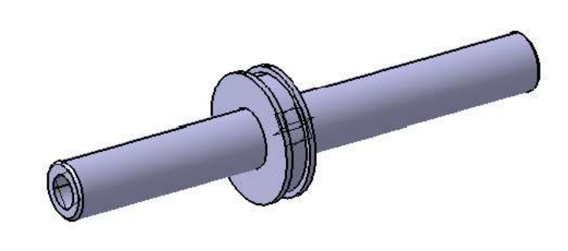

Figure 3.1.CATIA model of piston rod

* 1. **DESIGN OF ACTUATOR BODY**

The body is having some extra material for mounting of the servo valve it is considered as a cylinder for the analysis purpose. The inside diameter of the body is chosen as follows. The working pressure is selected as 210bar. The load pressure is taken as 200bar assuming that about 10bar is back pressure.

The maximum load =98066.5N

Proof test pressure =31.5 N/

Back pressure of the fluid =0.2N/

The maximum force (P) = π/4**p

98066.5= π/4**31.5

d =62.9 mm or 64 mm

Where d is inner diameter of the body and d1 is the outer diameter of the piston rod.

d1 = 28mm

The Inner Diameter is selected as 64 mm as per MIL-G-5514 to accommodate the composite seal selected. Now we can find the Outer Diameter by considering it as a pressure vessel subjected to internal pressure. As the proof pressure of 3.15Kgf/mm² is applied to cylinder calculation is done using proof pressure.

Thickness t = (p.d)/ (2ft)

= 31.5 * 64/2 * 965 = 1.044 mm

A minimum thickness of 6mm is considered from machinability point of view and the Outer Diameter is taken as 76 mm.

Do = Di+2t

=64+2(6)

=76 mm

Now the Body is a cylinder with a wall thickness of 6mm and inner diameter of 100 mm.

T/D = 6/76= 0.07

T/D <0.07

The body should be considered as a thin pressure vessel.

Internal pressure =31.5 N/mm²

Inner Diameter of the Body =64 mm

Outer Diameter of the body =76 mm

The hoop stress induced in the body is fh =PD/2t

Longitudinal stress induced is f1 =PD/4t

And radial stress fr =P

Where P is internal pressure & D is Inner Diameter of the body

fh =(31.5x64)/(2x6) =168 N/mm²

fl = (31.5x64)/ (4x6) = 84 N/mm²

&fr= P = 31.5 N/mm²

According to von mises stress theory

2y² = (1 – 2)² + (2 – 3)² + (3 - 1)²

the equivalent stress isy = 119.25N/mm²

So the factor of safety is 965/119.25 = 8.09

* + 1. **CATIA MODEL OF ACTUATOR BODY**

Based on the above calculations and servo valve dimensions the design of actuator body is done by using CATIA.

**Dimensions of actuator body**

Internal diameter of the actuator body =64 mm

Outer diameter of the actuator body =76 mm

Thickness of the actuator body =6 mm

Length of actuator body =122mm

For mounting servo valve =47X55 mm

Thickness of the flange =18mm

Diameter of the flange =110 mm

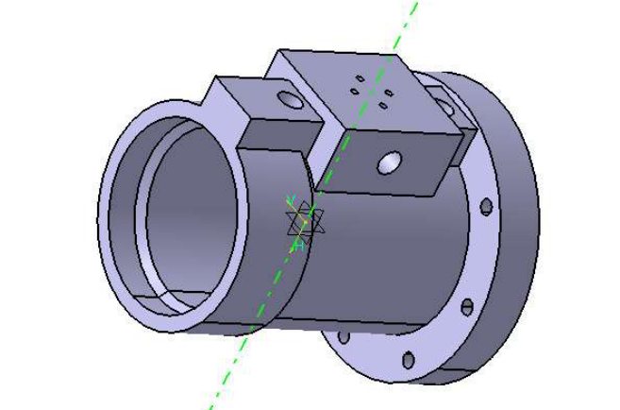

Figure 3.2.CATIA model of Actuator body

* 1. **DESIGN OF EYE END**

This Eye end is making two functions.

1. Acting as a head for hydraulic cylinder.
2. Taking the direct load

With the case (1) we can find the thickness of the flange with empirical formulae.

tc = d(K.P/ft)

PCD of bolts= 76 mm

P = Pressure= 31.5 N/mm²

Ft = 965 N/mm²

And for this particular mounting position

K = 0.162 (bolted joint)

tc = 76 × (0.162×31.5/100)

= 5.52 mm or 6 mm

The thickness of the flange is selected as 8 mm.

Stress induced in the flange is 490 N/mm²

Factor of safety is 1.96

It is safe.

Direct load of 98066.5 N is acting on the cover in return stroke. The Inner Diameter of the extended portion is selected as 38 mm to facilitate the free movement of the piston rod, and the Outer Diameter can be found as follows.

Cross sectional area of the Eye end = π/4(D² - 28²)

stress acting on the Eye end = 98066.5/π/4(D² - 28²)

Allowable Stress of the material = 965 N/mm²

965 = 98066.5/π/4(D² - 28²)

D = 30.21 mm

So a minimum thickness of 5mm is considered and Outer Diameter is taken as 40.21 mm.

The stress induced is =98066.5/π/4(40.21² - 28²)

=149 N/mm²

The Factor of safety is 6.43

The minimum factor of safety of the component is 2

* + 1. **DESIGN OF BODY WITH EYE END IN CATIA**

Based on the eye end calculations the design of eye end is done by using CATIA. It was acting like a head of the cylinder and trunnion end is hinged to the to the aerospace vehicle body.

**Dimensions of body with eye end**

Internal diameter of the body with eye end =30mm

Outer diameter of the body with eye end =42mm

Thickness of the flange =14mm

Diameter of the flange =110mm

Thickness of the eye end =8 mm

Length of the eye end =41mm

Total length of body with eye end =126mm

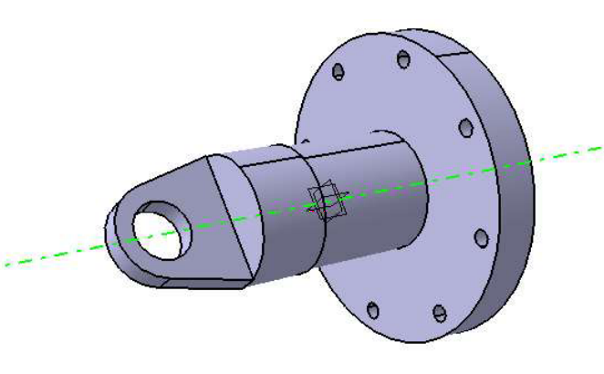

Figure 3.3.CATIA model of body with eye end

* 1. **DESIGN OF BOLT**

These bolts are used for fixing the Eye end to cylinder. Therefore on these bolts only direct stresses will be acting. Here bolts of 10.9 class were selected. The bolts are made with steel So the yield stress is 540 N/mm²

Tensile load during proof test is = 98066.5 N

No. of bolts (n) = 8

Core diameter = dc

Area (A) = π/4 dc²

Total area (n*A) = (π/4) x (dc²) x (8)

Tensile stress on the bolts =98066.5/ [(π/4) x dc² x 8)] Kgf/mm²

By equating it to the allowable yield stress of the material i.e. 540N/mm²

540= 98066.5 / (π/4 dc² ×8) N/mm²

.

So bolts of M8 X 40 are selected.

Core diameter dc = 6.466

Stress induced = 98066.5 / [(π/4× 6.466² ×8)]

= 373N/mm²

= 540/373

= 1.44

Length of the bolt can be selected from the induced shear stress in the threads.

Shear load : 98066.5 N

Shear load bearing area : πDtnN

Where D is Core diameter = 6.466 mm, pitch =1.25mm

t is thickness of the thread(take pitch/2) = 0.625mm

Where ‘n’ is no of threads in contact

N is no of bolts

Shear stress : 98066.5/π DtnN

Allowable shear stress: 270 N/mm²

Failure of the bolt should not occur at the threads so the threaded length of the bolts is chosen as 18 mm to make more no of threads to be in contact.

No of threads in contact is 12.

Induced shear stress : 98066.5/ (π x6.466 x0.625 x12 x8)

: 80.46N/mm²

Factor of safety : 6.711

* + 1. **DESIGN OF HEXAGONAL BOLT AND NUT IN CATIA**

The design of hexagonal bolt and nut depends on the core diameter and thickness of the flange. The bolts are used for fixing the eye end for cylinder. Here we are choosing M8 X 40 type of hexagonal bolt and M8 type of hexagonal nut.

**Dimensions of M8 X 40 hexagonal bolt**

Core diameter ( dc ) =6.466mm

Pitch( p ) =1.25mm

Thickness of the thread (t) =0.625

No of hexagonal bolts =8

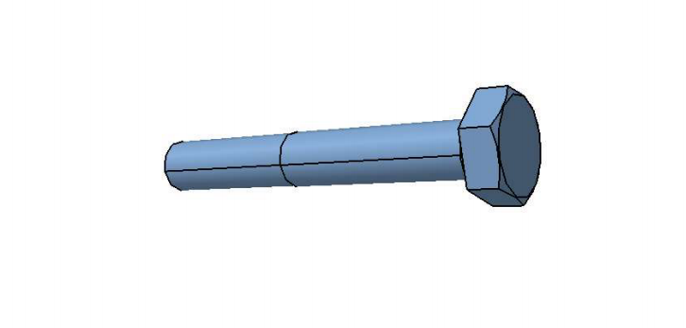

Figure 3.4 CATIA model of hexagonal bolt

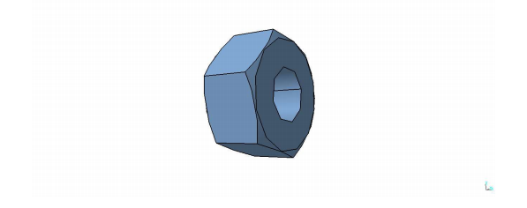

Figure 3.5 CATIA model of hexagonal nut

* + 1. **CATIA MODEL OF AN EYE BOLT**

The clevis end of the eye bolt is hinged to the aerospace vehicle nozzle and another end of the eye bolt is fixed to the piston rod. The complete assembly of piston rod and eye end will move the aerospace vehicle nozzle due to internal pressure obtained inside the body**.**

**Dimensions of eye end**

Diameter of eye bolt =16mm

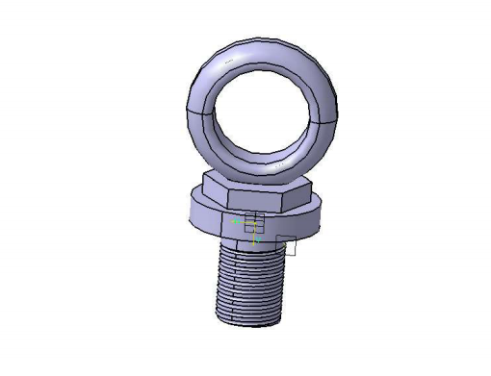

Figure 3.6. CATIA model of eye bolt

* + 1. **CATIA MODEL OF A LOCK NUT**

The locknut is used for closing the actuator body chamber.it prevents the leakage of hydraulic fluid with help of gland.

**Dimensions of locknut**

Outer diameter of lock nut =30 mm

Internal diameter of lock nut =70mm

Width of lock nut =20mm

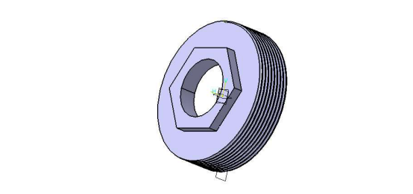

Figure 3.7. CATIA model of a lock nut

* + 1. **CATIA MODEL OF PISTON RING**

A piston ring is a split ring that fits into a groove on the outer diameter of a [piston](https://en.wikipedia.org/wiki/Piston) in a actuator body.

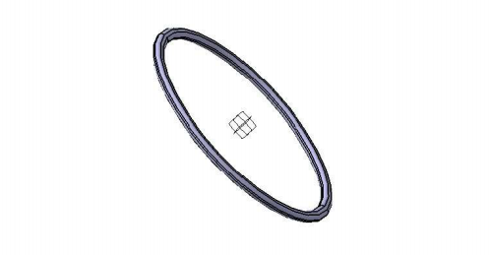

Figure 3.8. piston ring

* 1. **ASSEMBLY OF HYDRAULIC ACTUATOR IN CATIA**

Creating a model begins with a sketch. Form the sketch, you can create features. You can combine one or more features to make a part. Then, you can combine and mate the appropriate parts to create an assembly. Form the parts or assemblies, you can then create drawings.

The above design of the individual parts of the hydraulic actuator such as piston rod, body of actuator, eye bolt, etc. are taken and are assembled in CATIA.

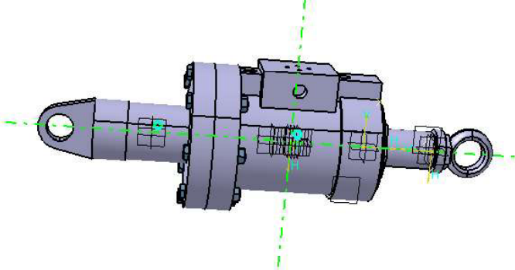

Figure 3.9. assembly of hydraulic actuator

1. **RESULTS AND DISCUSSIONS**

The above CATIA models are taken and structural analysis for the individual components are performed.

Analysis is the process of breaking a complex topic or substance into smaller parts to gain a better understanding of it i.e.…, the process of separating something into its constituent elements.

* 1. **STRUCTURAL ANALYSIS**

Structural analysis is the determination of the effects of loads on physical structures and their components. Structural analysis incorporates the fields of applied mechanics, materials science and applied mathematics to compute a structure's deformations, internal forces, stresses, support reactions, accelerations, and stability. The results of the analysis are used to verify a structure's fitness for use, often saving physical tests.

* 1. **STRUCTURAL ANALYSIS FOR PISTON ROD**

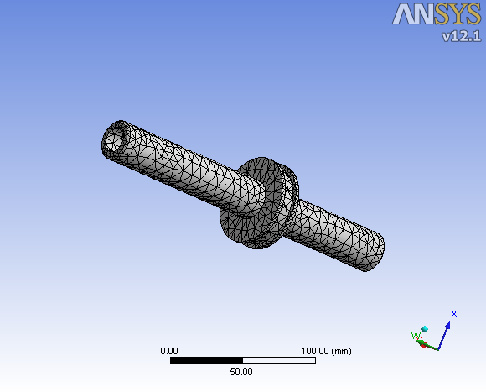

Figure 4.1 Meshing model of a piston rod

Meshing is an integral part of the computer-aided engineering (CAE) simulation process. The mesh influences the accuracy, convergence and speed of the solution. The figure 4.1 shows the meshing model of piston rod. Furthermore, the time it takes to create a mesh model is often a significant portion of the time it takes to get results from a CAE solution. Therefore, the better and more automated the meshing tools, the better the solution.by using mesh we determine the number of nodes and elements of overall component.

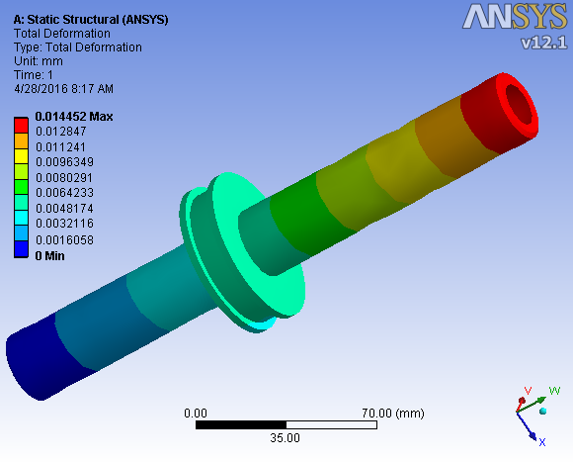

Figure 4.2 Total deformation of a piston rod

The above figure 4.2 shows the total deformation of a piston rod. Here obtained maximum deformation value is 0.014452 mm and minimum deformation value is 0.0016058 mm.

The piston is the moving part of an actuator which will move the load. Here the external pressure acting on the piston rod it is subjected to tensile stress, compressive stress and shear stresses induced due to fluid pressure.

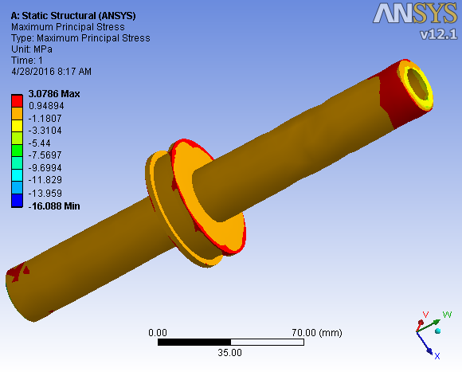

Figure 4.3 Maximum principal stress of a piston rod

The above figure 4.3 shows the maximum principal stresses of the piston rod. The piston rod is subjected to 210 bar of an external pressure where the maximum value obtained is 3.0786 N/mm2 and the minimum value obtained is -16.088 N/mm2. Here the maximum allowable stress of the material is 965 N/mm2.

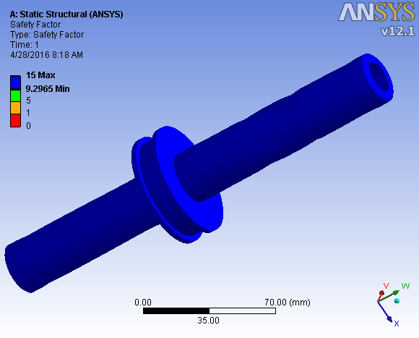

Figure 4.4 Factor of safety value of a piston rod.

The figure 4.4 shows the factor of safety values of the piston rod when subjected to an external pressure of 210 bar. The minimum FOS value of the piston rod obtained is minimum value is 9 and the maximum value is 15.

* 1. **STRUCTURAL ANALYSIS FOR ACTUATOR BODY**

Meshing is an integral part of the computer-aided engineering (CAE) simulation process. The mesh influences the accuracy, convergence and speed of the solution.

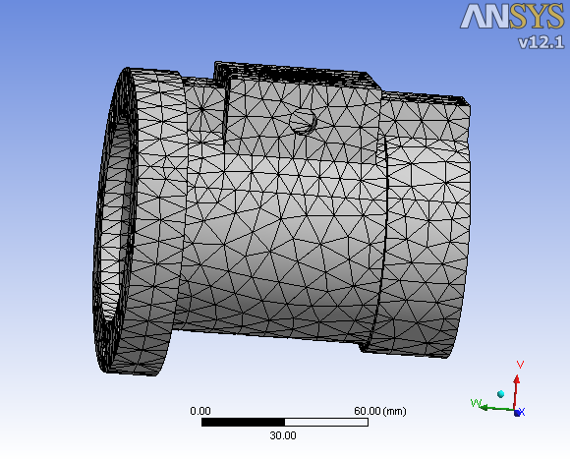

Figure 4.5 Meshing of an actuator body

The figure 4.5 shows the meshing model of an actuator body. Furthermore, the time it takes to create a mesh model is often a significant portion of the time it takes to get results from a CAE solution. Therefore, the better and more automated the meshing tools, the better the solution.by using mesh we determine the number of nodes and elements of overall component.

The equivalent von-mises stresses for the actuator body are calculated and the results obtained are shown in the figure 4.5 mentioned below. Here the actuator body is subjected to an internal working pressure of 210 bar and a force of 98066.5 N. here the actuator body is subjected to hoop stress, longitudinal stress and radial stress.

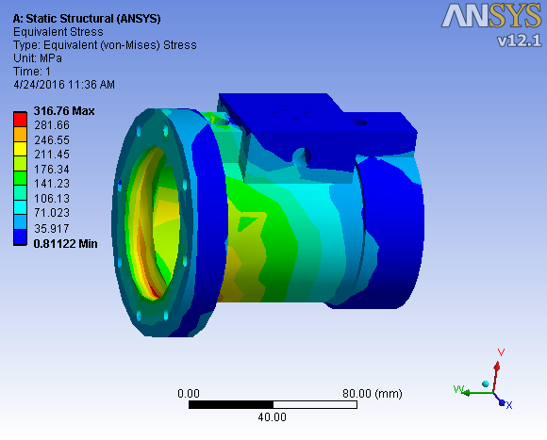

Figure 4.5.Equivalent Stress Analysis for Actuator Body

Here the above figure 4.5 shows the equivalent stress analysis of an actuator body, where the maximum tensile yield strength is 316.76 N/mm2and minimum tensile yield strength is 35.91 N/mm2.

Figure 4.6 shows the equivalent elastic strain values, where the maximum value of the static structural analysis is 0.0015838mm and minimum equivalent elastic strain structural analysis value is 0.4516 E-6mm

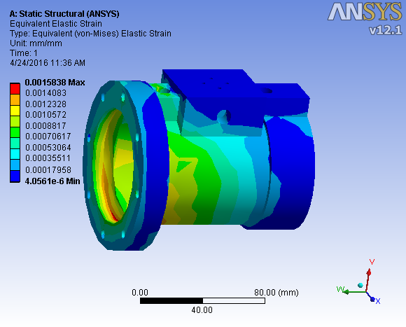

Figure 4.6 Equivalent elastic strain analysis of an actuator body

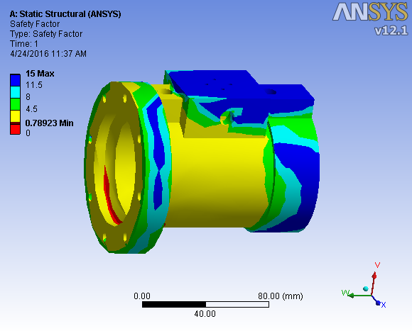

Figure 4.7 Factor of safety value of an actuator body

Figure 4.7 shows the factor of safety values of an actuator body when subjected to an external pressure of 210 bar. The minimum FOS value of the piston rod obtained is 0.78923 and the maximum value is 15.

The yield strength of an actuator body material is 965 N/mm2.The maximum value obtained by taking von mises theory into consideration is 316.76 N/mm2.Therefore the factor of safety obtained by taking these values into consideration is 3.0464.

The structural static analysis of the components of an actuator under the given loads and boundary conditions are taken to meet the CAE acceptance criteria, the working stress is less than the ultimate tensile strength and corresponding Factor of safety is 3.0464.

As per the material taken the factor of safety value for the analysis purpose should lie between 3 to 5. Hence the component meets CAE criteria so we conclude that the design is safe.

1. **CONCLUSION**

The Hydraulic Actuators used in Aerospace Vehicle is based on static loads was designed and various components are modelled using CATIA and analysed by ANSYS.

It is observed that the maximum Stresses, Strains and Displacements are obtained and the Components Piston, Body, Eye End, Bolt are Modelled.

Hence the results are obtained and the Design is Safe for 98066.5 N and is Satisfactory within the Acceptable limits.

An Aerospace vehicle is capable of flight both within and outside the sensible atmosphere. An Actuation system is one of the most important systems of an Aerospace vehicle. This project involves the detailed study of various control actuation systems and design of a typical hydraulic actuation system.

An actuator control system is any electrical, electronic or electromechanical system used to activate the actuator and control the direction, extent and duration of its output. Actuator control systems may take the form of extremely simple, manually operated start and stop stations, or sophisticated, programmable computer systems.

Hydraulic actuation systems contains electro hydraulic actuators, servo valves, feedback sensing elements, pump motor package, hydraulic reservoir, accumulator, various safety valves, filters etc.

In this project an elaborate study has been made with regard to design of hydraulic actuator in aerospace vehicle. Further the criteria for the selection of materials have been analysed. Design of the system includes design of hydraulic actuator and also the modelling and analysis of actuator using sophisticated software.

1. **REFERENCES**
2. Joshi, A. and Pramodh, Modelling and Simulation of Launch Vehicle Digital Autopilot, AIAA Paper No. 4696, Proc. Of .Modeling and Simulation Technologies Conference, Monterey, CA, USA, 6-8 August 2002
3. E. Papadopoulos, a systematic methodology for optimal component selection of Electro hydraulic servosystems International journal of fluid power, volume 5 number 3,November 2004 page 31-39.
4. Edson Roberto, design and experimental evaluation of position controllers for hydraulic actuators: backstepping and LQR-2DOF controllers International journal of fluid power, volume 5, number 3, November 2004 ,page 41-53.
5. Kexiangwei, Fluid Power Control Unit Using Electro rheological Fluids, International journal of fluid power, volume 5, number 3, November 2004, page61-69.
6. Holger Berndt, Interactive Design and Simulation Platform for Flight Vehicle Systems Development, IEEE Transactions on Control Systems Technology, Vol. 12, No. 2,March 2004, pp. 250–262.
7. Joshi, A. and Jayan, P.G., Modelling and Simulation of Aircraft Hydraulic System, AIAA Paper No. AIAA-2002-4611, Proc. of Modelling and Simulation Technologies Conference, Monterey, CA, USA, 6-8 August 2002. 7. Randall T. Anderson Mathematical Modeling of a Two Spool Flow Control Servovalve Using a Pressure Control Pilot, ASME journal, volume 124, September 2004.
8. Peter Rowland, M. Longvitt modular design approach for modeling of large and complex hydraulic systems ,International journal of fluid power, volume 12, number 4,August 2005, pp 134-152.
9. Sreeraj P.N, simulation work for typical aircraft’s steering system and wheel brake system, journal of AIAA, volume 121, November2001, pp. 153-172.
10. Panagiotis , detailed model of an electro hydraulic servo system International journal of fluid power, volume 5, number 2,september 2004, pp 121-138.
11. Ing T.Hong, Dynamic analysis for calculating hydraulic system response, Moog Technical Bulletin132, November 1975.
12. Paul J.Heney, challenges in aircraft hydraulic system, Moog Technical Bulletin142, August 1978.
13. Ming Yuan –Tsuei, application of computer programs for system design and analysis,International journal of fluid power, volume 7, number 4, September 2005, pp.143-158. .
14. P.Krus, A.Jansson, computer simulation for optimization of hydraulic components, International journal of fluid power, volume 12, number 4, November2005, pp162-183.
15. Joseph N.Demarchi, development of aircraft light weight hydraulic systems, journal of AIAA, volume 113, Dec 2001, pp. 123-132.
16. Jk Kapur, Mathematical Modeling,Prentice -Hall, New Delhi, 1993.
17. Yeaple, F, Fluid Power design Handbook, Marcel Decker, New York, 1995